**NCBA Mshwari New Scorecard TRS Document**

**Prepared by: Kenedy Manga Ogola**

**Reviewed by: Stanley Muthama**

NCBA Mshwari Scoring TRS Document

Prepared by: Kenedy Manga

Reviewed by: Stanley Muthama

1. **Objective**

Mshwari new scorecard functionality is to allow for the change to new scoring parameters that have been introduced by Safaricom Scoring API. The new parameters will allow distinguishing the good and the bad customers. The old parameters were built long time ago and therefore, has since deteriorated overtime.

1. **Scope.**

Required scope of changes:

* API Scoring Changes at Gateway level
* NEO PMML Changes----According to Safaricom spec.
* NEO Code change----To accommodate the new fields
* Defaulter List to retire oracle BI DB. - Mshwari Scoring engine jar file **@Benson** to review if there is any code required.

On the NEO side, the following components will be changed.

**2.1 NEO parameters change.**

These are the current old parameters on NEO.

**Old parameters.**

|  |  |
| --- | --- |
| **Request Field** | **Field type** |
| MSISDN | VARCHAR |
| Response_Code | NUMBER |
| Response_Desc | STRING |
| First_Name | STRING |
| Last_Name | STRING |
| Document_ID | STRING |
| MPESA_MSISDN | NUMBER |
| DATA_EXTRACTION_DATE | CHAR |
| RANDOM_ID | NUMBER |
| NETWORK_REGISTRATION_DATE | NUMBER |
| NETWORK_PAYMENT_TYPE | VARCHAR2 |
| DAYS_AIRTIME_LESS_THAN_10 | NUMBER |
| DAYS AIRTIME_LESS_THAN_2 | NUMBER |
| NETWORK_AIRTIME_UTILIZATION | NUMBER |
| DAYS_FROM LAST ACTIVITY | NUMBER |
| NUMBER_OF_ACTIVITY_DAYS | NUMBER |
| NETWORK_TOPUP_AVG_AMOUNT | NUMBER |
| NETWORK_TOPUP_MODAL_METHOD | VARCHAR2 |
| NETWORK NUM_POSTPAID_BLOCKED | NUMBER |
| NETWORK_POST_PAID_LIMIT | NUMBER |
| NETWORK_TOWN | VARCHAR2 |
| OKOA_JAHAZI_NUM_OF_OVERDUE | NUMBER |
| OKOA_JAHAZI_BLACKLISTED_DAYS | NUMBER |
| OKOA_JAHAZI_TOTAL_LOAN_TERM | NUMBER |
| OKOA_JAHAZI_MAXIMUM_TERM | NUMBER |
| OKOA_JAHAZI_FIRST_USE_RECENT | VARCHAR2 |
| OKOA_JAHAZI_LAST_USE_RECENT | VARCHAR2 |
| OKOA_JAHAZI_LAST_BL_RECENT | VARCHAR2 |
| MPESA_REGISTRATION_DATE | DATE |
| MPESA_RECEIVED_ACCEPTORS | NUMBER |
| MPESA_RECEIVED_HIGHEST | NUMBER |
| CURRENT_BONGA_PTS_BAL | NUMBER |
| SAMBAZA_AIRTIME_RCVD | NUMBER |
| TOTAL_CALLS_1_MNTH | NUMBER |

The new changes should accommodate the below new parameters on the PMML.

**New parameters**

|  |  |
| --- | --- |
| **Request Field** | **Field Type** |
| MSISDN | VARCHAR |
| MSISDN | VARCHAR |
| Response_Code | INT |
| Response_Desc | STRING |
| First_Name | STRING |
| Last_Name | STRING |
| Document_ID | STRING |
| MPESA_MSISDN | NUMBER |
| EXTRACTION_DATE | NUMBER |
| KYC_MSISDN | NUMBER |
| DOB | NUMBER |
| MPESA_REGISTRATION_DATE | NUMBER |
| NETWORK_REGISTRATION_DATE | NUMBER |
| NUMBER_OF_ACTIVITY_DAYS | NUMBER |
| MPSA_DEPOSIT_AMOUNT_6M | NUMBER |
| MPSA_DEPOSIT_AMOUNT_3M | NUMBER |
| MPSA_DEPOSIT_NUMBER_6M | NUMBER |
| MPSA_WITHDRAW_AMOUNT_6M | NUMBER |
| MPSA_WITHDRAW_NUMBER_6M | NUMBER |
| MPSA_RECEIVED_ACCEPTOR_6M | NUMBER |
| MPSA_SEND_AMOUNT_6M | NUMBER |
| MPSA_SEND_NUMBER_6M | NUMBER |
| MPSA_SEND_ACCEPTORS_6M | NUMBER |
| MPSA_TRAN_FROM_BANK_AMOUNT_6M | NUMBER |
| MPSA_TRAN_FROM_BANK_AMOUNT_3M | NUMBER |
| MPSA_TRAN_FROM_BANK_NUMBER_3M | NUMBER |
| MPSA_TRAN_FROM_BANK_ACCEPT_6M | NUMBER |
| MPSA_PAY_BILL_AMOUNT_6M | NUMBER |
| MPSA_PAY_BILL_NUMBER_6M | NUMBER |
| MPSA_BUY_GOODS_AMOUNT_6M | NUMBER |
| MPSA_BUY_GOODS_NUMBER_6M | NUMBER |

**PMML Changes.**

The old PMML document.



The new modified PMML document should look like below



**2.2 Scoring engine changes**

* The scoring engine will be required to read the new PMML file generated by NEO.
* Append the new parameters to the new PMML file created within the scoring engine.
* The scoring engine will then regenerate the scorecards based on the new PMML file.
* The scoring engine will return the scorecard to Neo.

1. **Mshwari Scorecard New Registration Process(Flow Diagram)**

Step 1:

* 1. Customer opt-in in Mshwari/Fuliza during the registration process.
  2. The opt-in process is forwarded to Safaricom.
  3. The opt-in request is then forwarded to Neo.
  4. In Neo the successful opt-in response is taken back to Safaricom
  5. Neo requests for the new credit scoring API.
  6. Safaricom responds with the new credit scoring API new response.
  7. Neo feeds the PMML with the new data.
  8. Neo requests queries for the defaulted status on the defaulted status on the BI database repo.
  9. The BI database repo returns the defaulted status as their Y or N to Neo.
  10. Neo updates the PMML with the new data.
  11. Neo then sends the PMML file to the scoring engine.
  12. Then the PMML file is appended to the scoring engine.
  13. The scoring engine will generate the new scorecard.
  14. The new score card is sent to Neo.
  15. Neo then captures the customers limit.
  16. Neo updates the new customer’s limit.
  17. The new limit is sent to the customer through Neo in a text message.

**MSHWARI SCORING FLOW DIAGRAM**

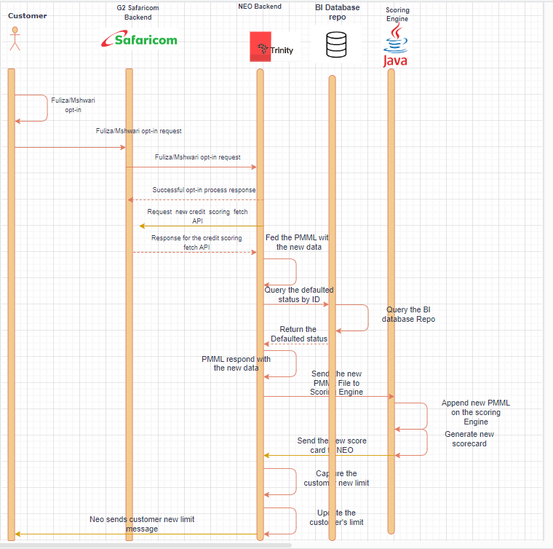

1. **API Capability**

New Mshwari Scorecard Request API.

**Request Sample.**

<?xml version="1.0" encoding = "UTF-8"?>

<ns0:Request xmlns:ns0 = "http://xmlns.example.com/1341933774185">

    <Request>

        <sch:DataRequest xmlns: SOAP-ENV = "http://schemas.xmlsoap.org/soap/envelope/" xmlns:sch="http://www.tibco.com/schemas/CreditScoring/SharedResources/Schemas/Schema.xsd" xmlns:soapenv ="http://schemas.xmlsoap.org/soap/envelope/">

            <sch:MSISDN-796825983</sch:MSISDN>

        </sch:DataRequest>

    </Request>

</ns0:Request>

<?xml version="1.0" encoding = "UTF-8"?>

<ns0: Response xmlns:ns0 = "http://xmlns.example.com/1341933774185">

**Response Sample**

<SOAP-ENV:Envelope xmlns:SOAPENV="http://schemas.xmlsoap.org/soap/envelope/">

    <SOAP-ENV:Body>

        <ns0:DataResponse xmlns:ns0="http://www.tibco.com/schemas/CreditScoring/SharedResources/Schemas Schema.xsd">

            <ns0:MSISDN>797553179</ns0:MSISDN>

            <ns0:Response_Code>0</ns0:Response_Code>

            <ns0:Response_Desc>Success</ns0:Response_Desc>

            <ns0:BioDataResponse>

                <ns0:First_Name>Esther</ns0:First_Name>

                <ns0:Last_Name>Kinara</ns0:Last_Name>

                <ns0:Document_ID>3977720</ns0:Document_ID>

                <ns0:Mpesa_MSISDN>797553179</ns0:Mpesa_MSISDN>

            </ns0:BioDataResponse>

            <ns0:DataItem>

                <ns0:ParameterName>EXTRACTION_DATE</ns0:ParameterName>

                <ns0:ParameterValue>20240111</ns0:ParameterValue>

                <ns0:ParameterType>NUMBER</ns0:ParameterType>

            </ns0:DataItem>

            <ns0:DataItem>

                <ns0:ParameterName>KYC_MSISDN</ns0:ParameterName>

                <ns0:ParameterValue>797553179</ns0:ParameterValue>

                <ns0:ParameterType>NUMBER</ns0:ParameterType>

            </ns0:DataItem>

            <ns0:DataItem>

                <ns0:ParameterName>DOB</ns0:ParameterName>

                <ns0:ParameterValue>19700101</ns0:ParameterValue>

                <ns0:ParameterType>NUMBER</ns0:ParameterType>

            </ns0:DataItem>

            <ns0:DataItem>

                <ns0:ParameterName>MPSA_REGISTRATION_DATE</ns0:ParameterName>

                <ns0:ParameterValue>20220925</ns0:ParameterValue>

                <ns0:ParameterType>NUMBER</ns0:ParameterType>

            </ns0:DataItem>

            <ns0:DataItem>

                <ns0:ParameterName>NETWORK_REGISTRATION_DATE</ns0:ParameterName>

                <ns0:ParameterValue>20220925</ns0:ParameterValue>

                <ns0:ParameterType>NUMBER</ns0:ParameterType>

            </ns0:DataItem>

            <ns0:DataItem>

                <ns0:ParameterName>NUMBER_OF_ACTIVITY_DAYS</ns0:ParameterName>

                <ns0:ParameterValue>10</ns0:ParameterValue>

                <ns0:ParameterType>NUMBER</ns0:ParameterType>

            </ns0:DataItem>

            <ns0:DataItem>

                <ns0:ParameterName>MPSA_DEPOSIT_AMOUNT_6M</ns0:ParameterName>

                <ns0:ParameterValue>0</ns0:ParameterValue>

                <ns0:ParameterType>NUMBER</ns0:ParameterType>

            </ns0:DataItem>

            <ns0:DataItem>

                <ns0:ParameterName>MPSA_DEPOSIT_AMOUNT_3M</ns0:ParameterName>

                <ns0:ParameterValue>0</ns0:ParameterValue>

                <ns0:ParameterType>NUMBER</ns0:ParameterType>

            </ns0:DataItem>

            <ns0:DataItem>

                <ns0:ParameterName>MPSA_DEPOSIT_NUMBER_6M</ns0:ParameterName>

                <ns0:ParameterValue>0</ns0:ParameterValue>

                <ns0:ParameterType>NUMBER</ns0:ParameterType>

            </ns0:DataItem>

            <ns0:DataItem>

                <ns0:ParameterName>MPSA_WITHDRAW_AMOUNT_6M</ns0:ParameterName>

                <ns0:ParameterValue>0</ns0:ParameterValue>

                <ns0:ParameterType>NUMBER</ns0:ParameterType>

            </ns0:DataItem>

            <ns0:DataItem>

                <ns0:ParameterName>MPSA_WITHDRAW_NUMBER_6M</ns0:ParameterName>

                <ns0:ParameterValue>0</ns0:ParameterValue>

                <ns0:ParameterType>NUMBER</ns0:ParameterType>

            </ns0:DataItem>

            <ns0:DataItem>

                <ns0:ParameterName>MPSA_RECEIVED_AMOUNT_6M</ns0:ParameterName>

                <ns0:ParameterValue>0</ns0:ParameterValue>

                <ns0:ParameterType>NUMBER</ns0:ParameterType>

            </ns0:DataItem>

            <ns0:DataItem>

                <ns0:ParameterName>MPSA_RECEIVED_AMOUNT_3M</ns0:ParameterName>

                <ns0:ParameterValue>0</ns0:ParameterValue>

                <ns0:ParameterType>NUMBER</ns0:ParameterType>

            </ns0:DataItem>

            <ns0:DataItem>

                <ns0:ParameterName>MPSA_RECEIVED_NUMBER_6M</ns0:ParameterName>

                <ns0:ParameterValue>0</ns0:ParameterValue>

                <ns0:ParameterType>NUMBER</ns0:ParameterType>

            </ns0:DataItem>

            <ns0:DataItem>

                <ns0:ParameterName>MPSA_RECEIVED_ACCEPTORS_6M

                </ns0:ParameterName>

                <ns0:ParameterValue>0</ns0:ParameterValue>

                <ns0:ParameterType>NUMBER</ns0:ParameterType>

            </ns0:DataItem>

            <ns0:DataItem>

                <ns0:ParameterName>MPSA_SEND_AMOUNT_6M</ns0:ParameterName>

                <ns0:ParameterValue>0</ns0:ParameterValue>

                <ns0:ParameterType>NUMBER</ns0:ParameterType>

            </ns0:DataItem>

            <ns0:DataItem>

                <ns0:ParameterName>MPSA_SEND_NUMBER_6M</ns0:ParameterName>

                <ns0:ParameterValue>0</ns0:ParameterValue>

                <ns0:ParameterType>NUMBER</ns0:ParameterType>

            </ns0:DataItem>

            <ns0:DataItem>

                <ns0:ParameterName>MPSA_SEND_ACCEPTORS_6M</ns0:ParameterName>

                <ns0:ParameterValue>0</ns0:ParameterValue>

                <ns0:ParameterType>NUMBER</ns0:ParameterType>

            </ns0:DataItem>

            <ns0:DataItem>

                <ns0:ParameterName>MPSA_TRAN_FROM_BANK_AMOUNT_6M

                </ns0:ParameterName>

                <ns0:ParameterValue>0</ns0:ParameterValue>

                <ns0:ParameterType>NUMBER</ns0:ParameterType>

            </ns0:DataItem>

            <ns0:DataItem>

                <ns0:ParameterName>MPSA_TRAN_FROM_BANK_AMOUNT_3M

                </ns0:ParameterName>

                <ns0:ParameterValue>0</ns0:ParameterValue>

                <ns0:ParameterType>NUMBER</ns0:ParameterType>

            </ns0:DataItem>

            <ns0:DataItem>

                <ns0:ParameterName>MPSA_TRAN_FROM_BANK_NUMBER_6M

                </ns0:ParameterName>

                <ns0:ParameterValue>0</ns0:ParameterValue>

                <ns0:ParameterType>NUMBER</ns0:ParameterType>

            </ns0:DataItem>

            <ns0:DataItem>

                <ns0:ParameterName>MPSA_TRAN_FROM_BANK_ACCEPT_6M

                </ns0:ParameterName>

                <ns0:ParameterValue>0</ns0:ParameterValue>

                <ns0:ParameterType>NUMBER</ns0:ParameterType>

            </ns0:DataItem>

            <ns0:DataItem>

                <ns0:ParameterName>MPSA_PAY_BILL_AMOUNT_6M</ns0:ParameterName>

                <ns0:ParameterValue>0</ns0:ParameterValue>

                <ns0:ParameterType>NUMBER</ns0:ParameterType>

            </ns0:DataItem>

            <ns0:DataItem>

                <ns0:ParameterName>MPSA_PAY_BILL_NUMBER_6M</ns0:ParameterName>

                <ns0:ParameterValue>0</ns0:ParameterValue>

                <ns0:ParameterType>NUMBER</ns0:ParameterType>

            </ns0:DataItem>

            <ns0:DataItem>

                <ns0:ParameterName>MPSA_BUY_GOODS_AMOUNT_6M</ns0:ParameterName>

                <ns0:ParameterValue>5</ns0:ParameterValue>

                <ns0:ParameterType>NUMBER</ns0:ParameterType>

            </ns0:DataItem>

            <ns0:DataItem>

                <ns0:ParameterName>MPSA_BUY_GOODS_NUMBER_6M</ns0:ParameterName>

                <ns0:ParameterValue>30</ns0:ParameterValue>

                <ns0:ParameterType>NUMBER</ns0:ParameterType>

            </ns0:DataItem>

        </ns0:DataResponse>

    </SOAP-ENV:Body>

</SOAP-ENV:Envelope>

